Nursing Research Section (NRS), Te Wāhanga Rangahau Tapuhi
Annual Research Forum
Thursday, 10 October 2024, Taite, 10 Oketopa 2024

“Hoki whakamuri, kia anga whakamua
Look at the past to help forge the future.”
Understanding knowledge is not old or confined but continues to be relevant and evolve.

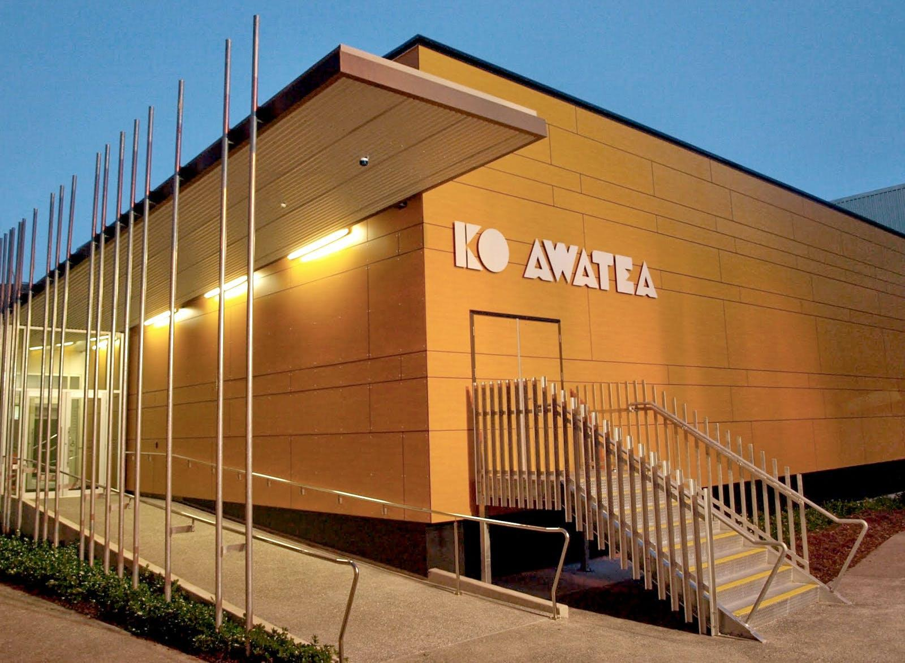

Ko Awatea, Middlemore Hospital, HealthNZ Counties Manukau, Tamaki Makaurau
The Forum’s kaupapa encompasses the many and varied ways in which nurses, neehi
undertake inquiry to improve the services we deliver,
outcomes for health consumers and how we practice in the future.

Registration fees for Forum:
Te Wāhanga Rangahau Tapuhi welcomes koha
Want to join NRS NZNO? Kei te hiahia koe ki te whakauru mai?
Click here or copy the link:
www.nzno.org.nz/groups/colleges_sections/sections/nursing_research_section/join_us

Please submit your 150-250 word abstract to nzno.nrs@gmail.com using the form below BEFORE:
5 pm on Friday, 26 July, 5 pm a te Paraire, 26 Hōngongoi 2024.

NURSING RESEARCH SECTION ABSTRACT SUBMISSION FORM
Your abstract will be assessed against the following criteria:
- Relevance to the conference kaupapa.
- Applied research, rangahau that demonstrates valued outcomes to stakeholders.
- Meets one of the following categories:
  - Early career researcher/ kairangahau
  - Established senior researcher/ kairangahau

Email address, īmerā
Presenter’s Name, kaiwhakataki ingoa
Biography/ies, haurongo
Institution (affiliation), hononga
Co-author & collaborator,
ingoa and hononga
Abstract title, taitara
Abstract, taitara (150-250 words):
Please submit in this format, where applicable:
- Aims
- Background
- Methods
- Results/Findings
- Conclusion
- Implications for nursing
Forum category, kaupapa (please indicate)
- Early career researcher, kairangahau
- Established senior researcher, kairangahau

